CSIT314 Software Development Methodologies - Group Project

Sprint 1 - US9: View user account
Interior Design Platform - User Admin
All diagrams were drawn in draw.io. Open "US9 View user account.drawio" in this folder to edit them - each diagram is its own page in that file. The exported images are in the "diagrams" folder.

Assumptions
- The system is the Interior Design Platform from the project specification. Sprint 1 covers the User Admin's stories: log in and log out (US1, US2), managing user profiles (US3 - US7) and managing user accounts (US8 - US12).
- A user account is one person's login. It has a username, password, full name, email, phone, the user profile (group) it belongs to, a status (Active or Suspended) and the date it was created. Every account belongs to exactly one user profile and gets that profile's permissions.
- We follow B-C-E: the actor only talks to the boundary (page), the boundary only talks to the controller, and the controller works with the entity classes. There is one controller per use case.
- Who checks what: the boundary (page) takes the userId from the link and shows what comes back - there is no typed input to check. The controller just calls the entity and returns the result (the account, or None). The entity reads the database.
- Being logged in as a User Admin (UC1) is a precondition, not a step: loginRequired in app.py only sends someone with no session to /login, and this use case doesn't check the role again.
- The account's user profile (group name) belongs to US4. So the page borrows US4's ViewUserProfileController.getUserProfile() for it, instead of the US9 controller fetching it.
- The User Admin opens an account from the accounts list or the search results (UC12), so the userId is already known.
- The details page shows the username, full name, email, phone, the user profile (group) name, the status and the created date. The password is never shown, not even the hash.
- Suspended accounts can still be viewed. Viewing doesn't change any data.

1. User story
Story ID | US9
User story | As a user admin, I want to view a user account so that I can check the user's details, group, and account status.
Actor | User Admin
Priority | High
Story points (estimate) | 2
Acceptance criteria | 1. Given I click "View" on an account, then I see its username, full name, email, phone, user profile, status and created date.  2. The password is never shown.  3. Suspended accounts can be viewed too, with status "Suspended".  4. Given the account doesn't exist (e.g. a wrong link), then I see "Account not found".  5. From the details page I can go to Update (US10) or Suspend (US11).
Tasks | #294 Draw View User Account Use Case Diagram  #295 Write View User Account Use Case Description  #296 Draw View User Account BCE Diagram  #297 Draw View User Account Sequence Diagram  #298 Design View User Account Wireframe  #299 Write and Execute View User Account Test Cases

2. Use case diagram
The user story becomes one use case, UC9 View user account. The User Admin is the only actor.
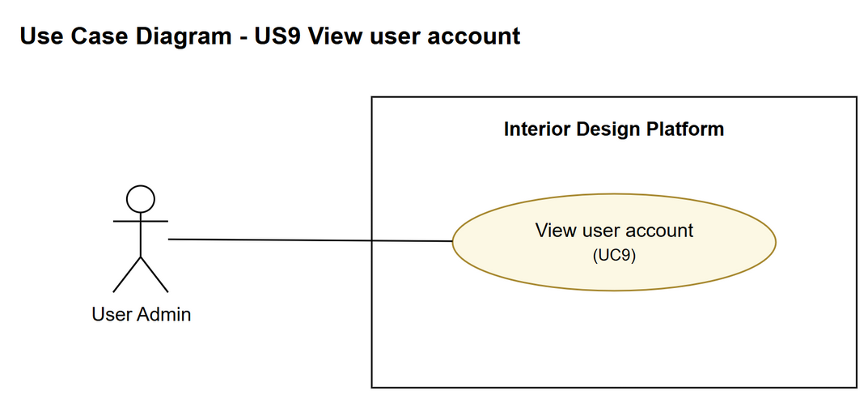
Figure 1: Use case diagram for US9 View user account

3. Use case description
Use case | UC9 View user account
Actor | User Admin
Brief description | The User Admin opens one user account to check the user's details, group and status.
User story | US9: As a user admin, I want to view a user account so that I can check the user's details, group, and account status.
Preconditions | The User Admin is logged in (UC1).  The User Admin is on the accounts list or the search results (UC12).
Trigger | The User Admin clicks "View" on a user account.
Basic flow | 1. The User Admin clicks "View" on a user account.  2. The system gets the account.  3. The system gets the user profile the account belongs to (as in UC4 View user profile).  4. The system shows the account's details, the profile name, the status and the created date.
Alternative flows | 2a. The account doesn't exist: the system shows "Account not found".
Postconditions | Nothing in the system is changed.

4. Wireframes
The wireframes were drawn in draw.io. They are low-fidelity: they show the layout and the flow, not the final colours. The orange numbers match the notes under each screen.

4a - User account details
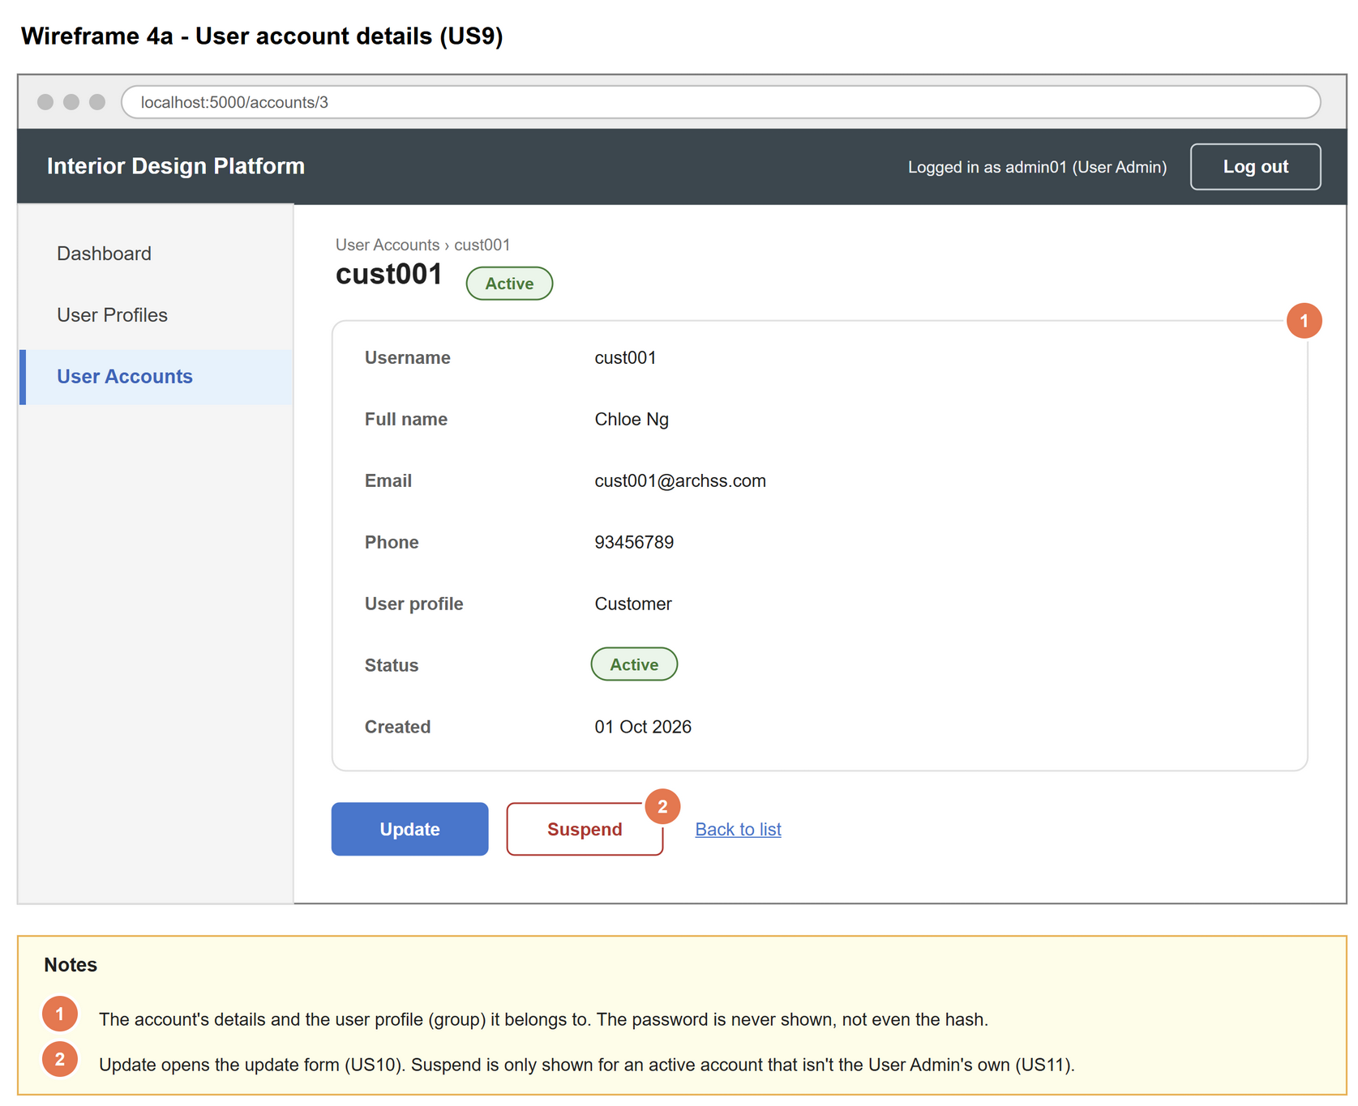
Figure 2: Wireframe 4a - User account details (US9)

4b - Account not found
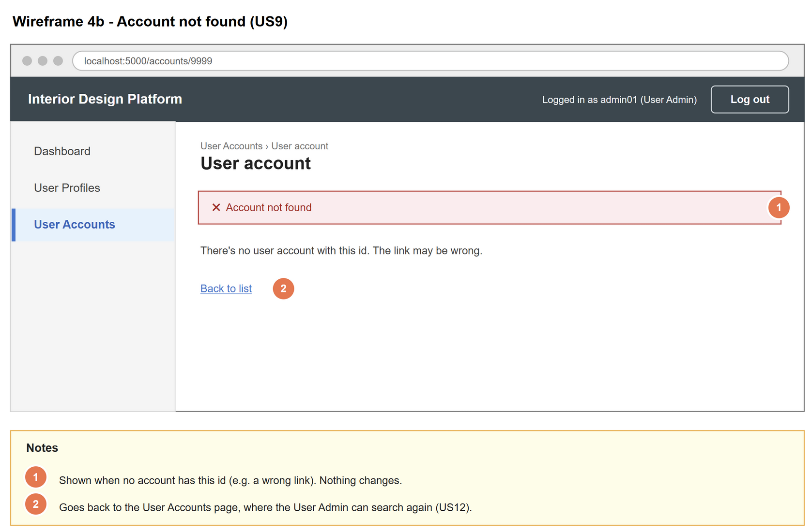
Figure 3: Wireframe 4b - Account not found (US9)

5. B-C-E class diagram
The solid lines mean the boundary calls a controller (its own one, and US4's ViewUserProfileController for the profile name). The dashed lines mean a controller uses an entity class. Only the operations needed for this use case are shown.
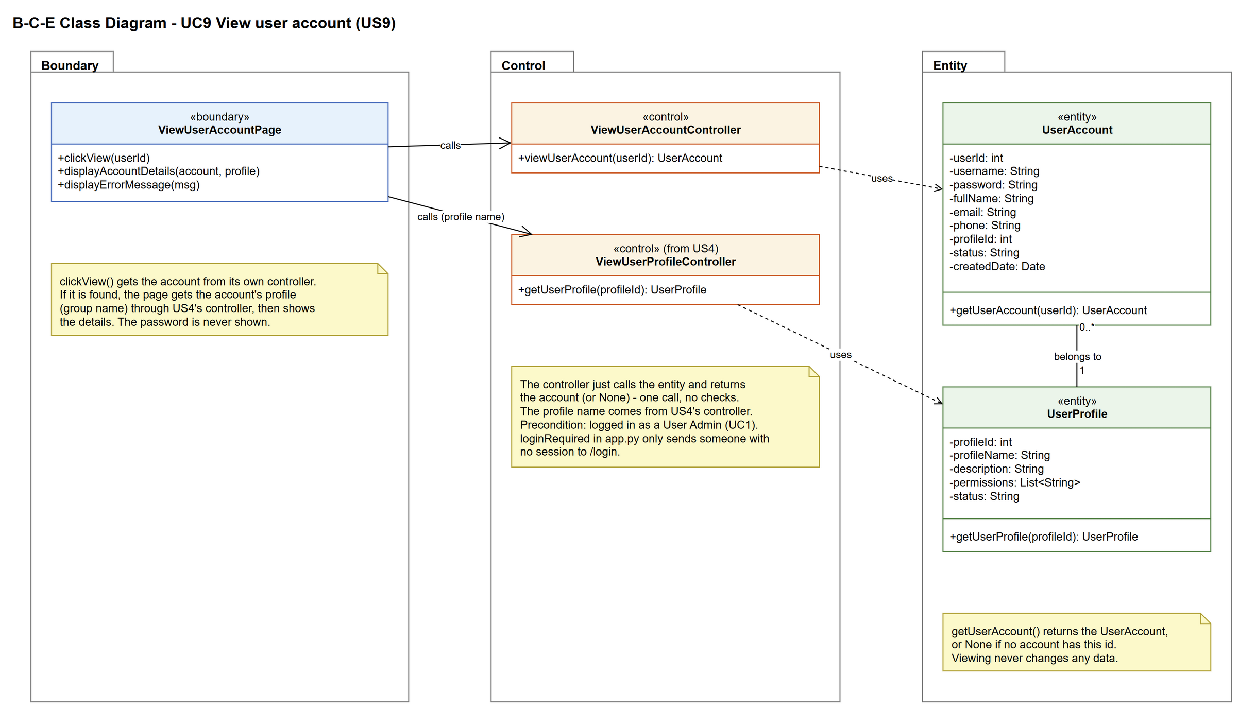
Figure 4: B-C-E class diagram for US9 View user account
Layer | Class | What it does
Boundary | ViewUserAccountPage | The account details page. Gets the account through its own controller. If it is found, gets the account's profile through US4's ViewUserProfileController and shows the details; if not, shows "Account not found".
Control | ViewUserAccountController | Controller for UC9. viewUserAccount(userId) just calls UserAccount.getUserAccount() and returns the account (or None) - one call, no checks.
Control | ViewUserProfileController (from US4) | Borrowed from US4. getUserProfile(profileId) returns the profile (group) the account belongs to.
Entity | UserAccount | getUserAccount() returns the account, or None if there is no account with that id.
Entity | UserProfile | getUserProfile() returns the group the account belongs to (1 to 0..* relationship).

6. Sequence diagram
The sequence diagram follows UC9. The note says the userId already comes from the list or the search (UC12). The controller gets the account and returns it straight away (step 2). The alt box at the page shows the two ways it can end: the account exists, so the page gets its profile through US4's ViewUserProfileController and shows the details (steps 3 and 4), or it doesn't exist and "Account not found" is shown (alternative flow 2a).
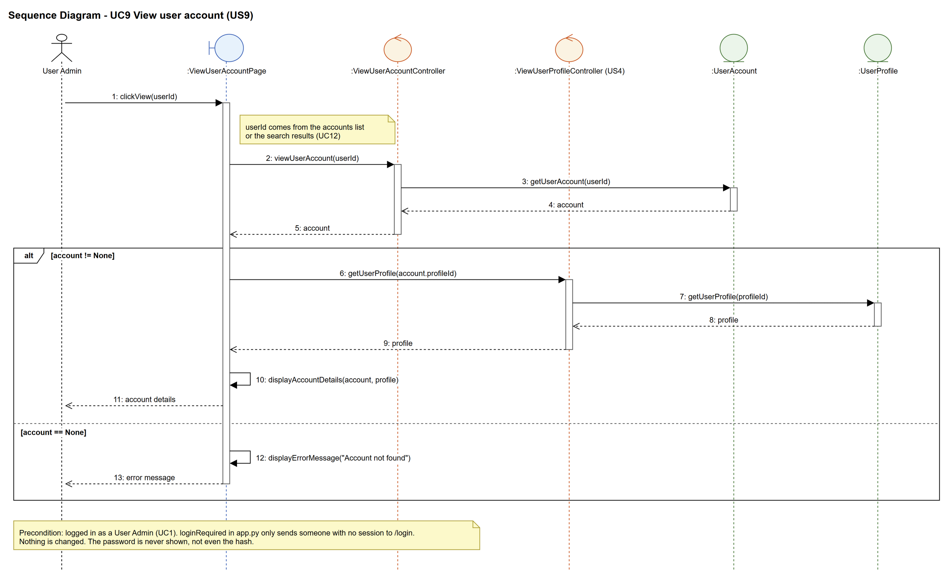
Figure 5: Sequence diagram for UC9 View user account

7. Test cases
Test data used below (same as database/seedData.py): user profiles User Admin (id 1), Interior Designer (id 2), Customer (id 3) and Platform Manager (id 4), all Active. User accounts admin01 / Admin@123 (id 1, User Admin, Active), admin02 / Admin@123 (id 2, User Admin, Suspended), cust001 / Cust@123 (id 3, Customer, Active) and designer1 / Pass@123 (id 4, Interior Designer, Active).

7a. System test cases (black box)
Equivalence partitioning and boundary value analysis were used to pick the test data. Fill in "Actual result" and "Pass/Fail" after running each test.
Test ID | Scenario | Prerequisites | Test steps | Test data | Expected result | Actual result | Pass / Fail
TC9.1 | View an active account | Logged in as admin01. | 1. Open the User Accounts page  2. Click "View" on cust001 | cust001 | Shows cust001, Chloe Ng, cust001@archss.com, 93456789, Customer, Active and the created date.
TC9.2 | Password is not shown | Logged in as admin01. | 1. View cust001 | cust001 | No password (or hash) appears anywhere on the page.
TC9.3 | View a suspended account | Logged in as admin01. | 1. View admin02 | admin02 | Shows Ben Lim, User Admin, status Suspended.
TC9.4 | Account doesn't exist | Logged in as admin01. | 1. Type the view page URL with userId 9999 | userId 9999 | "Account not found".
TC9.5 | Viewing changes nothing | TC9.1 done. | 1. Check the user_account table | cust001 | cust001's row is exactly the same as before.

7b. Unit test cases (for TDD)
These are written before the code (test-driven development) and run with pytest (python -m pytest). They cover normal inputs, abnormal inputs and boundary values.
Test ID | Class and method | Input / setup | Expected output | Type | Pass / Fail
UT9.1 | ViewUserAccountController.viewUserAccount() | 3 | Returns the account with username "cust001" | Normal | Pass
UT9.2 | ViewUserAccountController.viewUserAccount() | 2 | Returns admin02 with status "Suspended" | Normal | Pass
UT9.3 | ViewUserAccountController.viewUserAccount() | 9999 | Returns None (no error thrown) | Abnormal | Pass
UT9.4 | ViewUserAccountController.viewUserAccount() | 0 | Returns None | Boundary | Pass
UT9.4b | ViewUserAccountPage.clickView() | 3 (GET /accounts/3) | Shows cust001 with profile "Customer". The page gets the profile through US4's ViewUserProfileController - ViewUserAccountController only returns the account. | Normal | Pass
UT9.5 | UserAccount.getUserAccount() | 1 | Returns admin01 with profileId 1 | Normal | Pass
UT9.6 | UserProfile.getUserProfile() | 3 (cust001's profileId) | Returns the profile named "Customer" | Normal | Pass
UT9.7 | ViewUserAccountPage.clickView() | 3 (GET /accounts/3) | Shows cust001, Chloe Ng, cust001@archss.com, 93456789, Customer and Active | Normal | Pass
UT9.8 | ViewUserAccountPage.clickView() | 3 (GET /accounts/3) | Neither the password "Cust@123" nor its hash is on the page | Normal | Pass
UT9.9 | ViewUserAccountPage.clickView() | 2 (GET /accounts/2) | Shows admin02 (Ben Lim) with status "Suspended" | Normal | Pass
UT9.10 | ViewUserAccountPage.clickView() | 9999 (GET /accounts/9999) | "Account not found" is shown | Abnormal | Pass
UT9.11 | ViewUserAccountPage.clickView() | 3 (GET /accounts/3) | cust001's row in user_account is the same before and after | Normal | Pass

